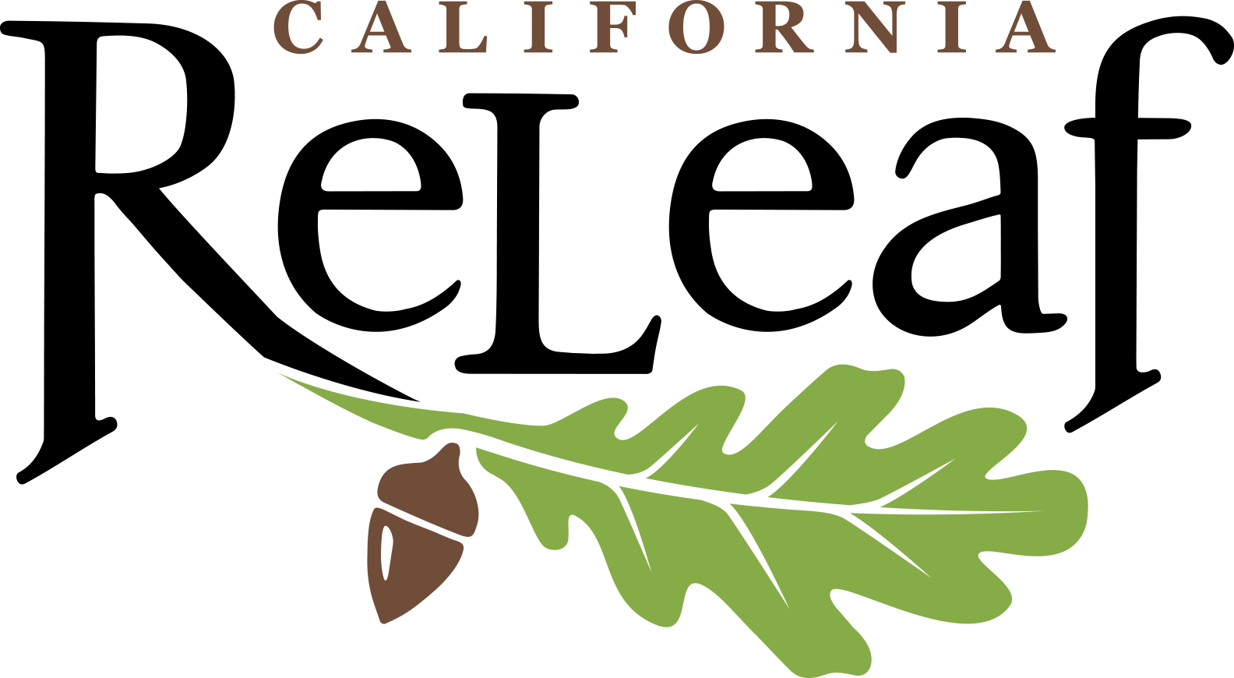
Questions on Treecovery Quarterly Progress Report

Link to Report: https://form.jotform.com/213015218652144

Section 1: Project information
Org Name
Project Name
Grant Agreement number
Name of Person filling out form
Email
Phone
Reporting Calendar Year
Reporting Quarter

Section 2: Project Data
Funds - as presented on Invoice Workbook
Funds expended this quarter
Match this quarter
Total of these.
Funds expended to date
Match to date
Total of these to date
Trees - as reported on MDCA workbook
Tree planted this quarter
Trees planted to date
How many of the trees planted were replacements?
Other Vegetation
Number of other plants this period
Number of plants to date

Section 3: Project Story
- Describe and quantify tree maintenance activities completed during this period.
- Describe other green infrastructure components completed during this period, if applicable (i.e. community gardens, plants, bioswales):
- Please indicate what workforce development and other co-benefits the grant funded during this project period. Check list and describe.
- Jobs created
- Individuals trained. Indicate if certificate earned
- Community Engagement
- Public health benefits
- Air quality improvement
- Reduced vehicle miles travelled
- Publications, web pages, or other materials created
- Policies improved
- Stormwater runoff reduced and/or treated (report in acre feet)
- Other
- Partnerships: please describe the role of project partners during this period. Be sure to indicate successes from the partnership. (Challenges should be captured in the Q7)
- A. List the census tract numbers where tree planting activities took place during this period. (from MDCA)
B. List the census tract numbers where other grant activities took place during this period.(Besides any tree planting census tracts listed above, share where education, outreach, training, etc. activities took place.)
C. List additional census tracts served during this period, and how. (For example, if you provided workforce development training in census tracts listed in 5B, but participants came from a larger surrounding area, those could be listed here.)
6. Describe activities completed during this period that helped build the capacity of your organization or supported a just economic recovery in your community:
7. Describe challenges faced. If they were overcome, please explain how.

Attachments
Photos
Other Materials
MDCA workbook (Trees planted)

